Project-Team:2
Team Members:
Priyanka B V
Sade Navalatha
Lagumsani Sravanthi
Neeruganti Chandana
Punna Ganesh

Online Grocery
Project Specification:

- Responsive SPA using React/ Angular.
- Application will support user, vendor and admin role. Use Angular either for admin or front end.
- Vendor will add grocery item under various category.
- Admin is responsible for adding categories in application.
- Admin will allow vendor to add products.
- User can add items in cart and order products.
- Admin will provide offers and discounts.
- Every purchase will add points to the user wallet. Can be reimbursed during billing once reach to some point.
- User will get offers information once logged in into this application based on their previous purchased items and amount spent.
- User can also schedule particular items for delivery.
- User will give feedback and ratings.
- User can communicate with admin and vendor to resolve their query once logged in.
Project Requirement
- Angular 13
JSON
Rest Web Services API
Modules:
1.HomePage
2.AboutUs
3.Categories
4.Product
5.Deals
6.Contact
7.Cart
8.Admin Login & Signup
9.Customer Login & Signup
10.Feedback

Design:
1.Homepage
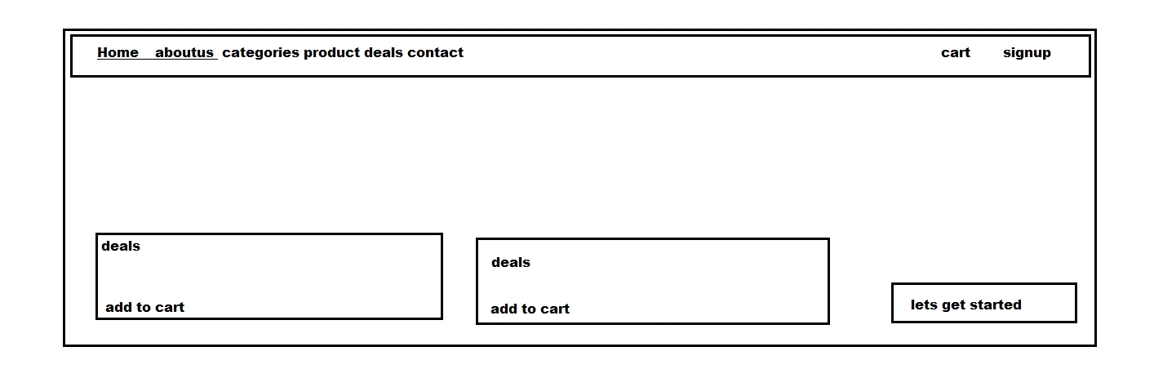
2.AboutUs
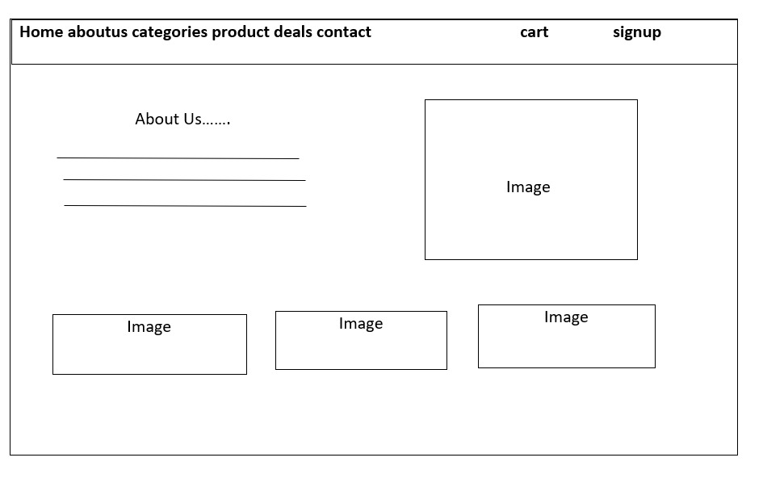
3.Categories

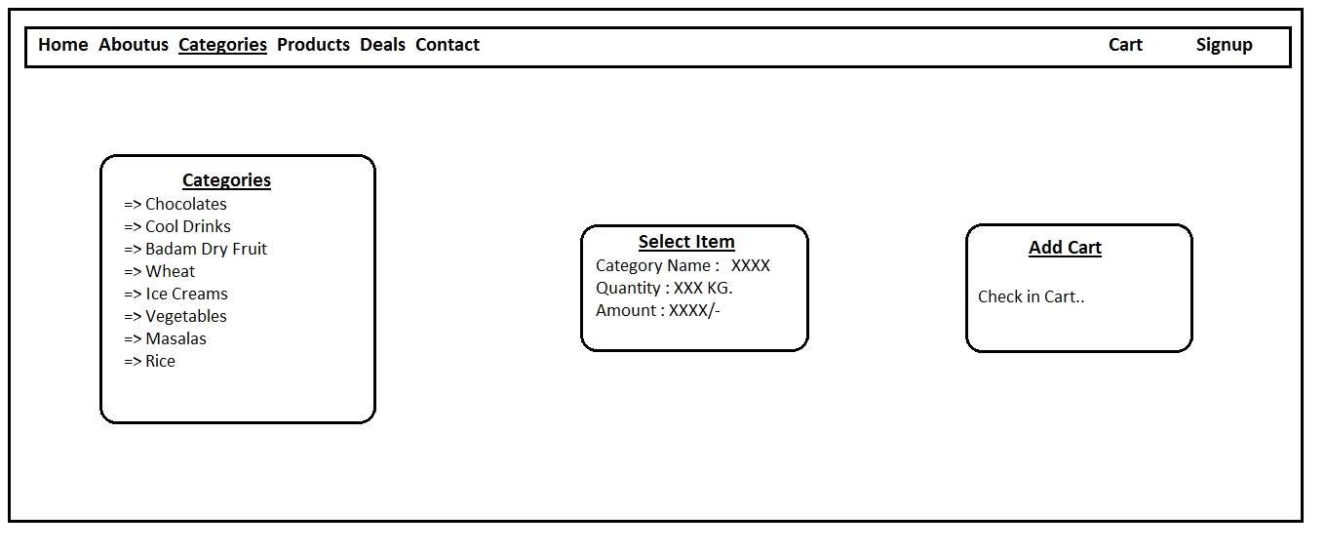
4.Product
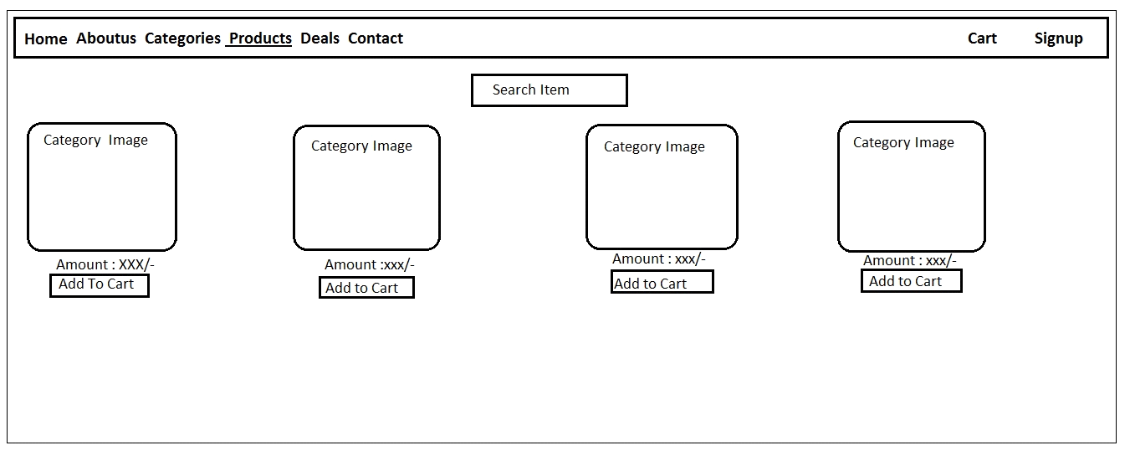
5.Deals
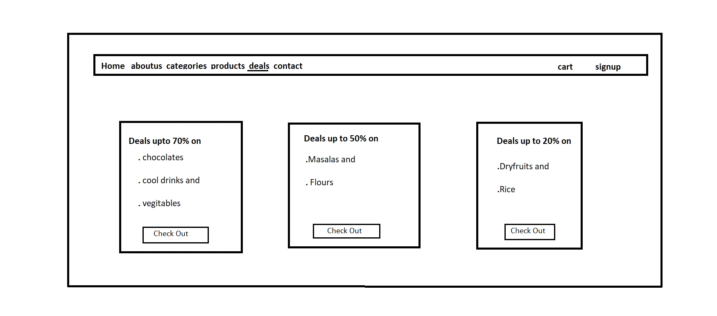
6.Contact
Home aboutus categories product deals contact cart signup

Contact

Name:

Contact no:

Address:

Message/queries:

7.Cart:
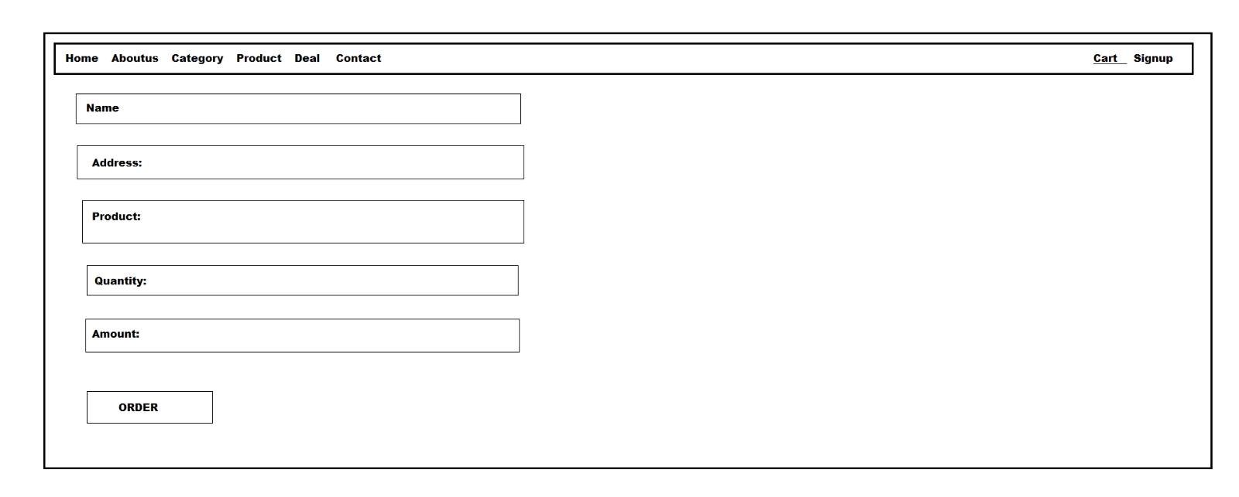8.Signup
